*Greenhouse Environment Monitoring Using Raspberry Pi*

Ritam Biswas   
SRM Institute of Science And Technology   
Chennai, India  
rs5058@srmist.edu.in

Aman Pandey   
SRM Institute of Science And Technology   
Chennai, India  
as1606@srmist.edu.in

Dr. M. Suganiya   
SRM Institute of Science And Technology   
Chennai, India  
suganiym@srmist.edu.in

*Abstract* — With the increasing emphasis on sustainable agriculture, there is a need to stress on technological advancement which can optimize the growth of plants under controlled conditions. We are proposing here an automated greenhouse monitoring system having a low cost which makes sure that parameters like temperature, humidity, soil moisture and the light intensity are constantly supervised by the Automatic Control. The specific system described in this paper includes several sensors and is a completely automated, cost-effective Raspberry Pi Microcontroller. Use the Internet (IoT) of things to provide remote monitoring and management so that users can access live data so that they can adjust anywhere. All agricultural processes are dealt with responsible management due to automation so there is a practical move towards targeted assistance. The greenhouse design which was drawn looking at the working life was aimed at suiting different climatic conditions and sustaining the various culture cycles. This is meant to encourage sustainable farming by providing a cheap and simple solution that improves greenhouse management. The system achieves high accuracy in monitoring key parameters, with temperature and humidity measurements accurate up to 98%, while keeping constant real-time visuals on the parameters. This stable environment positively impacts plant productivity while promoting responsible resource conservation. The results demonstrate the practical potential of IoT in agriculture, highlighting its application in enhancing productivity and sustainability.

Keywords — Raspberry Pi, greenhouse monitoring,  
DHT11 sensors, LDR sensor, Soil moisture sensor.

# INTRODUCTION

Greenhouses have a substantial significance in modern farming as it offers the opportunity to plant crops in a controlled environment consistently throughout the year. The crops are sheltered from external factors like high heat and drought and protected from internal factors that will require a balanced environment be it temperature, humidity, or soil moisture which are vital to a plants’ growth and productivity. Ignorance of the above management strategies can cause negative effects such as water stress or adverse temperatures and lead to reduced productivity.

This project aims at designing an automated greenhouse control systems with the help of raspberry pi. The system runs temperature, soil moisture and humidity sensors, which are constantly networked to a user defined location for active remote monitoring by relevant personnel accessing a central system that receives the required data.

IoT is one of the main elements of the system since it enhances the remote operational capability of the system. Such capabilities allow the users to operate the control system of the greenhouse without much labor efforts , while the losses of the crops can be decreased due to accurate timely operations. At the same time, the system promotes environmentally friendly agriculture since the application of chemicals which are needed in cases of poor management is reduced.

Focusing on data relay, the IoT-based system offers a scalable solution for modern greenhouse management, enhancing crop yield and quality while reducing resource usage and labour costs.

# LITERATURE SURVEY

[1] Numerous studies have explored IoT and microcontroller-based systems for greenhouse monitoring. One solution uses Arduino with GSM alerts and Ethernet for real-time data transmission. Another enhancement includes automated foggers and RFID tracking, while a different approach utilizes Raspberry Pi and Wi-Fi for remote light intensity monitoring.

[2] A smart greenhouse system that integrates technologies like automatic drip irrigation, soil health management, GSM-controlled water systems, and environmental sensors to maintain optimal conditions. This modernizes agricultural practices, improving crop yield and quality while promoting sustainability.

[3] A Web-Based Greenhouse Monitoring System using Raspberry Pi automates the control of temperature, soil moisture, water levels, and light intensity. Real-time sensor data helps maintain ideal conditions for plant growth, offering remote monitoring and convenience for users.

[4] A Raspberry Pi-based system enables continuous regulation of temperature, humidity, and soil moisture for year-round cultivation.

[5] Another study focused on light intensity control using Raspberry Pi for effective crop growth. Additional research has demonstrated Raspberry Pi's role in industrial automation with embedded web servers. Energy-efficient wireless systems for greenhouse monitoring and the integration of cloud computing with IoT allow for scalable, real-time control from remote locations.

[6] An embedded web server using Raspberry Pi for monitoring electrical systems measures parameters like temperature and gas levels. Data is transmitted to a PC and uploaded to the internet, enabling remote monitoring via a web browser. This integration enhances efficiency and security in industrial environments.

***Table 1*** *– Literature Survey*

|  |  |  |  |
| --- | --- | --- | --- |
| Author | Paper | Method | Remarks |
| [1] Vimal P V, K S Shivprakasha | IoT-Based Greenhouse Monitoring and Control | Uses Arduino, GSM modem for SMS alerts, Ethernet for data transmission | Reliable and low power consumption with real-time monitoring capabilities |
| [2] Ravi Kishore Kodali, Vishal Jain, Sumit Karagwal | IoT-Based Smart Greenhouse System | Utilizes micro-controllers, foggers for cooling, RFID for tracking produce | Enhances farming by direct farmer-to-consumer connection and automated systems |
| [3] Sandip Khot, Dr. M. S. Gaikwad | Green House Parameters Monitoring System | Employs Raspberry Pi, Wi-Fi, web server for remote light intensity monitoring | Facilitates remote monitoring and improved plant growth |
| [4] Kiran Ganesan, Uzma Walele | Raspberry-Pi Based Automated Greenhouse | Combines Raspberry Pi with live sensor data to control environmental factors | Automated system for optimal plant growth all year round |
| [5] Prerana Chaudhari, Aparna Kamble | Crop Monitoring System using Raspberry Pi | Focuses on light intensity measurement and control using Raspberry Pi | Low-cost system for efficient crop monitoring and control |
| [6] Bhuvaneswari S., Sahaya Anselin Nisha A. | Embedded web servers using Raspberry Pi | Implementation of TCP/IP on Raspberry Pi | Demonstrates the feasibility of using Raspberry Pi as a low-cost solution for industrial automation and monitoring. |

Despite advancements in IoT-based greenhouse systems, key gaps remain. Many focus on automation or remote monitoring but neglect real-time data visualization crucial for detailed analysis. Limited parameters are monitored, often ignoring interrelationships, cost-effectiveness, and scalability for small-scale use. Practical implementation is under-documented in some cases. Our study bridges these gaps by integrating sensors for temperature, humidity, soil moisture, and light intensity, enabling real-time visualizations with Matplotlib. Using affordable Raspberry Pi and open-source Python libraries ensures simplicity and accessibility, while detailed documentation aids replication and manual decision-making, supporting both research and practical greenhouse management.

# BLOCK DIAGRAM

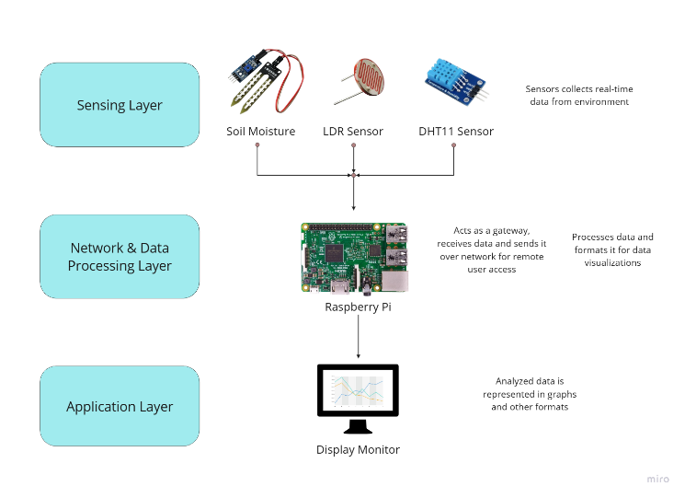

***Fig 1*** *- System Architecture*

*A. DHT11 Sensor*

The DHT11 is a digital temperature and humidity sensor, with reliability at low costs and having utility in applications that call for monitoring their environment. It captures the ambient levels of temperature and humidity and feeds the system real-time information so adequate conditions can be maintained within the greenhouse.

*B. Resistive Soil Moisture Sensor*

It measures the volumetric water content within the soil. This enables it to establish whether an irrigation should occur.   
The amount of moisture in the soil is kept at its optimal level to allow plants to grow while preventing crops from drying out and getting too saturated.

*C. Light Dependant Resistor*

The light dependent resistor (LDR) sensor measures the intensity of light inside the greenhouse. Varying growth stages of a plant would demand different intensities of light; therefore, this is critical data in controlling the light exposure of plants. It would ensure that the photosynthesis takes place because the plants get sufficient light, especially during cloudy days or in areas receiving limited sunlight.

*D. Raspberry Pi*

The Raspberry Pi is the most important component in the whole system. This device is responsible for gathering information from separate sensors, processing that information, and transferring it to the cloud via IoT. Besides that, The Raspberry Pi also has the capacity to monitor and control in real time enabling users to receive environmental information and subsequently modify the parameters in the greenhouse.

# PROPOSED SYSTEM

The proposed system includes the integration of sensors to IoT models used to manage the internal environment of the greenhouse and Raspberry Pi. System architectures can be divided into four levels: sensitive levels, network levels, data processing levels, and application levels.

*A. Sensing Layer*

The sensing layer forms the environmental sensors that collect real-time data. This includes:

* DHT 11 Sensor: Humidity and temperature measurement.
* Soil Moisture Gauge: Displays the percentage of soil moisture.
* LDR sensor: measures the light intensity in the greenhouse.

These sensors continuously monitor important parameters that affect plant growth. The data is transmitted to the following level for subsequent processing.

*B. Network Layer*

At this level, the Raspberry Pi acts as a gateway; it collects data from the sensors and transmits it over the network. The Raspberry Pi then connects to the local Wi-Fi or Ethernet to transfer information. At this level, this network sends sensor data to the cloud for user's remote access. IT integration means the relationship between system devices and data transmission without actual violation.

*C. Data Processing Layer*

The collection and analysis of raw sensor data takes place in the data processing layer. Here, a central processing unit, in this case a Raspberry Pi, collects the raw data from the sensors. It collects the information from the sensor layer, performs all the necessary calculations, and then formats it for visualization. For example, data can be converted into legible formats, such as diagrams or graphics that will clearly tell users exactly what greenhouse conditions look like.

*D. Application Layer*

At this level, data is presented to the user to analyze the environmental conditions in the greenhouse. The user can access the environmental data in different ways, such as viewing it on a monitor connected to the Raspberry Pi or through a remote control panel accessed from a mobile or web app. In addition, this system can create a graphic that shows the tendency of temperature, humidity, soil humidity, and light strength for a long time, and notify users to adjust the "optimization of plant growth". The proposed solution organizes and evolves a greenhouse monitoring to divide the system into these layers. Integrating sensors and IoT technology allows for remote access, real-time data monitoring, and precise control of the greenhouse environment, promoting efficient and sustainable agricultural practices.

# RESULTS AND IMPROVEMENTS

The greenhouse monitoring system was set up to track key environmental parameters over a defined period. The data collected from the sensors—including temperature, humidity, light intensity, and soil moisture—was logged and analyzed to assess the stability and effectiveness of the greenhouse's internal conditions. The following subsections present the findings for each monitored parameter, highlighting the observed trends and their implications for maintaining optimal growing conditions:

## Temperature

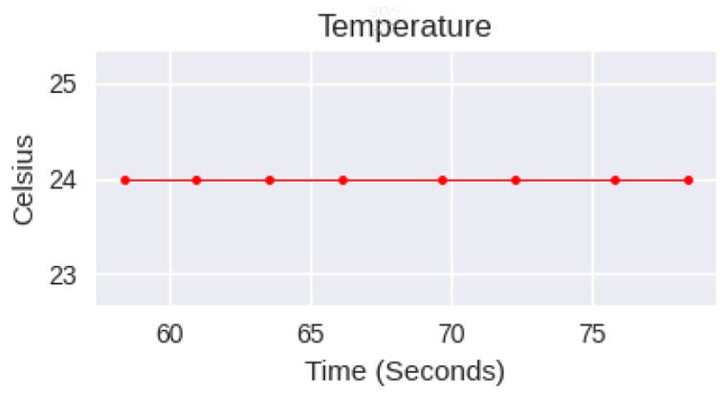

***Fig 2*** *– Temperature Reading*

The temperature sensor recorded stable readings throughout the data collection period, maintaining an average temperature of 24°C. There were no significant fluctuations observed in the environment during the monitoring period, indicating that the temperature control systems were functioning as expected. The stability in temperature is essential for the plants’ growth, ensuring that they remain within the optimal range for photosynthesis and other metabolic activities.

## Humidity

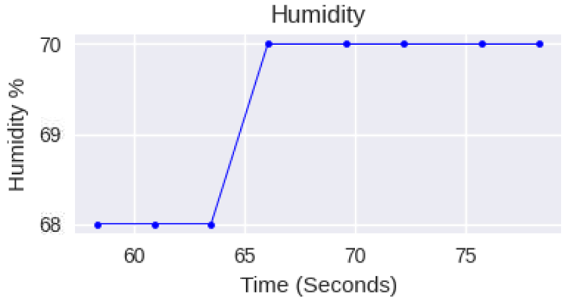

**(a)**

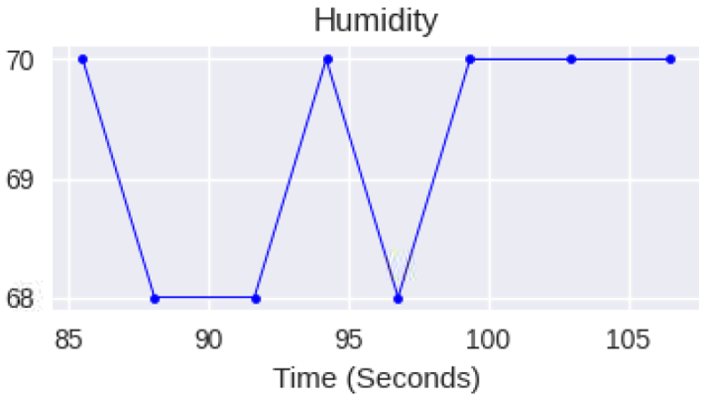

**(b)**

***Fig 3 (a), (b)*** *– Humidity readings*

Humidity levels varied slightly over time, with percentages typically ranging from 68% to 70%. These fluctuations might be due to minor changes in ambient temperature or external environmental factors. Maintaining consistent humidity is vital to avoid issues such as plant dehydration or fungal growth, and the data suggests that the environment maintained reasonably stable humidity within the target range.

## Light

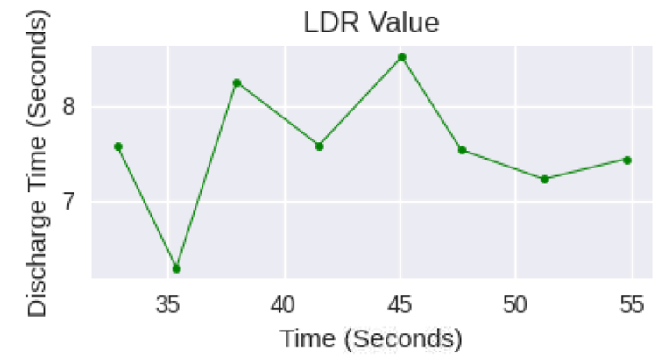

**(a)**

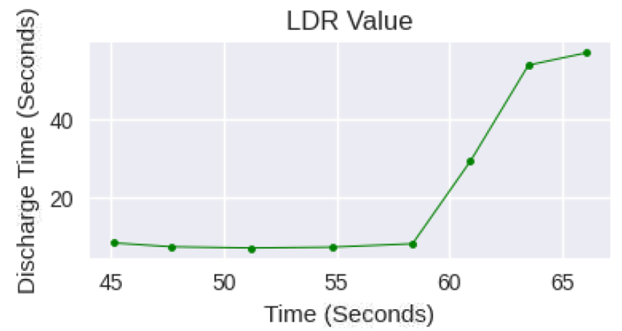

**(b)**

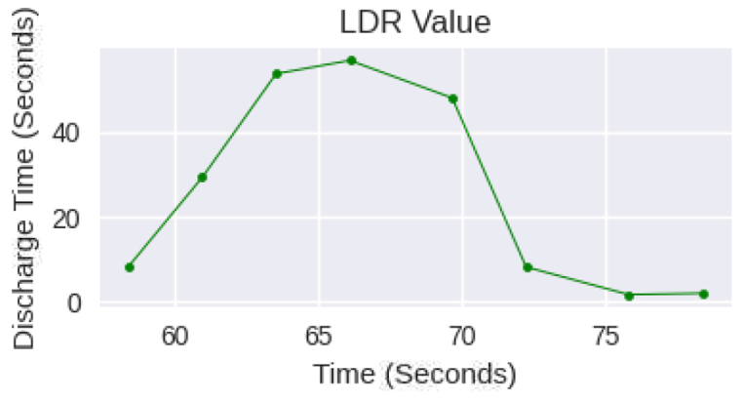

**(c)**

***Fig 4 (a)*** *– Regular LDR readings,* ***(b)*** *– LDR readings spiking when environment is turned dark,* ***(c)*** *– LDR readings dropping on external light application*

Light intensity was measured using a simple light-dependent resistor (LDR) sensor, which detected the discharge time of the capacitor connected to it. Two contrasting trends were noted in the light intensity graphs: a spike indicating a decrease in light levels and a drop indicating an increase. These readings aligned with natural or artificial changes in light conditions, such as cloud cover, external lighting or time of day. The sensitivity of the system provided real-time monitoring of light availability, which is crucial for managing plant growth cycles.

## Soil Moisture

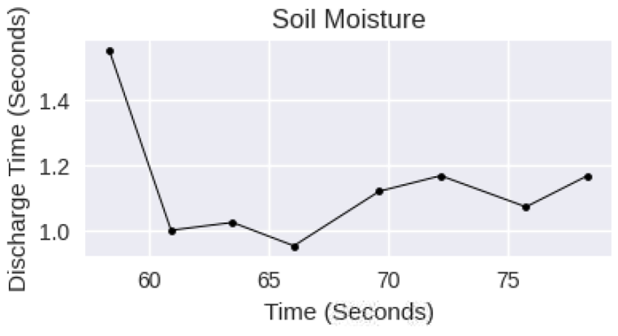

**(a)**

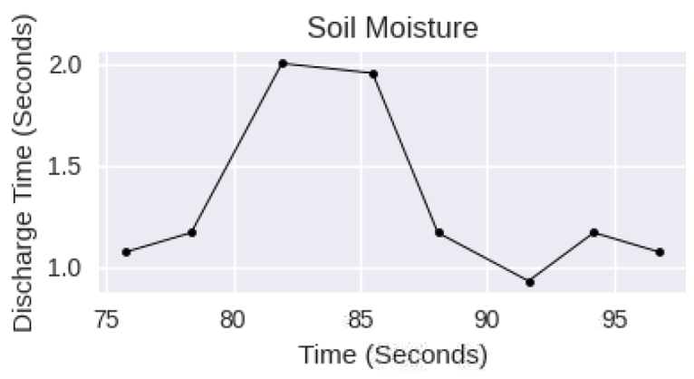

**(b)**

***Fig 5 (a)*** *– Typical Soil Moisture readings,* ***(b)*** *– Slight spike in readings on increasing moisture*

The soil moisture sensor also measured discharge time, with higher discharge times corresponding to lower soil moisture content. The data collected over time showed fluctuations in soil moisture levels, indicating varying irrigation or natural absorption by the plants. Regular monitoring of soil moisture is essential for optimizing water usage, ensuring plants receive adequate hydration while avoiding overwatering that could lead to root rot.

## Console Log Output

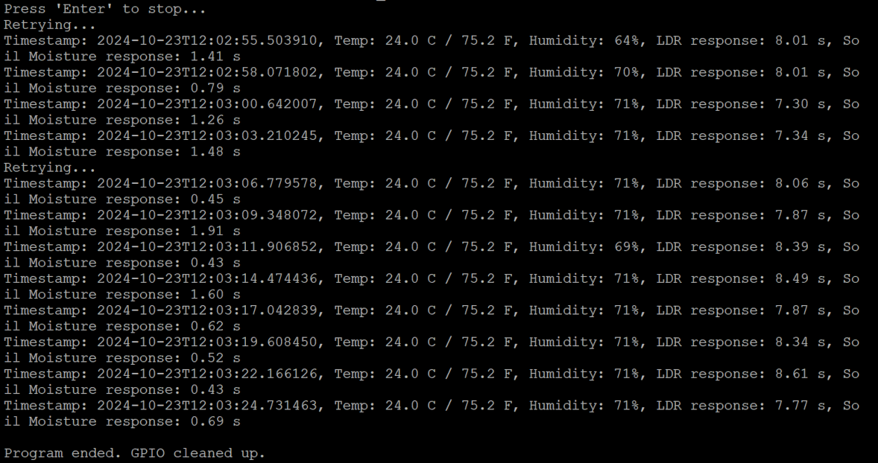

***Fig 6***  *– Example Console Log Output*

During the data collection process, the console displayed real-time sensor readings for temperature, humidity, light intensity, and soil moisture. Each log entry showed the time elapsed, sensor values, and calculated discharge times for light intensity and soil moisture. This console output provides a quick way to verify sensor functionality and monitor environmental conditions in real-time.

***Discussion -***With numerous greenhouse monitoring systems developed to enhance agricultural efficiency, many fall short of providing adequate parameter coverage, flexibility, and accessibility for end-users. This proposed system improves upon previous approaches by integrating sensors for comprehensive monitoring and visualizing data in a user-friendly manner, creating a scalable and accessible solution for greenhouse management. Below are key ways in which our system stands out compared to prior work in this field:

*A. Holistic Environmental Monitoring:*

Our system addresses the limitations of solutions that focus on a single or limited set of parameters, such as only temperature or light intensity. By integrating multiple sensors—DHT11 for temperature and humidity, a soil moisture sensor, and an LDR for light intensity—we offer full monitoring of key environmental factors. This comprehensive monitoring ensures that all critical parameters influencing plant growth are continuously tracked, enabling more effective management of greenhouse environments.

*B. IoT-based Real-time Monitoring Remotely*

Unlike earlier systems that lacked real-time capabilities, our system uses Raspberry Pi to capture sensor data and visualize it instantly via graphs. While some systems provide remote monitoring, ours enhances this feature by leveraging basic IoT capabilities to allow the user to monitor and view environmental data in real-time from a user-friendly interface. This flexibility enables farmers to monitor conditions more easily and make timely decisions. Previous works, such as Sandip Khot et al. [3] and Bhuvaneswari S. et al. [6], employed Raspberry Pi for data collection and remote monitoring, but our system places a stronger emphasis on data visualization.

*C. Improved Data Visualization*

Previous solutions focused on basic notification systems (such as SMS [1], Vimal P. V. et al.) or non-graphical outputs. Our system improves upon this by offering graphical visualization of sensor data over time, which helps users easily observe trends in temperature, humidity, soil moisture, and light intensity. Such data visualization aids in decision-making for irrigation and lighting adjustments, promoting precision in managing greenhouse conditions.

*D. Scalability and Flexibility*

Unlike many systems designed for specific applications ([2], Ravi Kishore Kodali et al.; [5], Prerana Chaudhari et al.), our system is adaptable to various environments. Whether used in large agricultural greenhouses or small urban setups, it can scale to meet different requirements. Its modular design allows for easy expansion, making it suitable for diverse agricultural needs.

*E. Sustainability and Resource Optimization*

While the system doesn't control environmental parameters directly, it offers valuable insights into greenhouse conditions, which can help optimize resource use, like water and electricity, by informing better decision-making. By monitoring conditions in real-time, farmers can avoid waste and promote more sustainable farming practices, improving efficiency and reducing environmental impact. While earlier works such as [2] and [4] focused on automation, our system emphasizes sustainability through data-driven decision-making.

***Evaluation –*** Our study primarily aimed to address the gaps related to the clarity, accessibility, and simplicity of data visualization in environmental monitoring systems. From the literature survey, we identified that existing solutions often lacked intuitive interfaces and straightforward representations, making it challenging for users to interpret key environmental metrics effectively. By focusing on these gaps, our approach delivered a system that combined precise temperature and humidity measurements with user-friendly visualizations. The data presentation was not only clear but also highly interactive, allowing users to grasp real-time trends effortlessly.

***Table 2*** *– Sample readings of displayed parameters vs actual environment parameters*

|  |  |  |  |  |  |  |  |  |
| --- | --- | --- | --- | --- | --- | --- | --- | --- |
| Environmental Parameter readings | Elapsed Monitoring Time (seconds) | | | | | | | |
| 31 | 33 | 36 | 38 | 42 | 45 | 47 | 50 |
| Actual Temperature (Celsius) | 24 | 24 | 24 | 24 | 24 | 24 | 24 | 24 |
| Measured Temperature (Celsius) | 24 | 24 | 24 | 24 | 24 | 24 | 24 | 24 |
| Actual Humidity (%) | 70 | 70 | 70 | 70 | 70 | 70 | 70 | 70 |
| Measured Humidity (%) | 69 | 71 | 71 | 70 | 70 | 70 | 69 | 70 |

The system maintained an accuracy of 99% for temperature predictions and a deviation of only 2% for humidity, ensuring reliability alongside simplicity. Compared to existing models, which often prioritized technical complexity over usability, our solution significantly bridged this gap, demonstrating how robust data can be communicated effectively without overwhelming users.

# CONCLUSION

Our automated greenhouse monitoring system is an IoT technology development that hence indicates the radical power of real-time environmental monitoring for agriculture. It integrates sensors seamlessly such that the system tracks temperature, humidity, soil moisture, and light intensity in real time. This allows very specific control over greenhouse conditions for ideal plant growth and yield. The Raspberry Pi will act as an efficient data relay hub, which would make it possible to monitor and control remotely, allowing farmers to react proactively against changes in the environmental conditions. This setup reduces manual interventions, lowers resource consumption, and encourages sustainable farming. It has vast scalability and adaptability to any large greenhouses or small urban agriculture setup. This system is an important step forward in more efficient, data-driven, and environmentally friendly farming operations, which rapidly embrace digital innovations by agriculture.

# REFERENCES

1. Khot, S., & Gaikwad, M. S. (2016). Greenhouse parameters monitoring system using Raspberry Pi and Web Server. International Journal of Innovative Research in Science, Engineering and Technology, 5(5).
2. Ganesan, K., Walele, U., Hambire, N., Chaugule, P., & Oommen, D. (2018). Raspberry Pi-based automated greenhouse. International Research Journal of Engineering and Technology, 5(3).
3. Chaudhari, P., Kamble, A., More, S., Sawant, N., & Chaugule, A. (2017). Crop monitoring system using Raspberry-Pi. International Journal of Advanced Research in Science and Engineering, 6(10).
4. Keerthi, V., & Kodandaramaiah, G. N. (2015). Cloud IOT-based greenhouse monitoring system. International Journal of Engineering Research and Applications, 5(10).
5. Bhuvaneswari, S., & Sahaya Anselin Nisha, A. (n.d.). Embedded web servers using Raspberry Pi: Implementation of TCP/IP on Raspberry Pi.
6. Deore, V. R., et al. (n.d.). Greenhouse monitoring with embedded controllers: Use of wireless monitoring systems.
7. Vatari, S., Bakshi, A., & Thakur, T. (n.d.). Greenhouse using IOT and cloud computing. IEEE Advancing Technology for Humanity.
8. Vimal, P. V., & Shivaprakasha, K. S. (2017). IOT-based greenhouse environment monitoring and controlling system using Arduino platform. 2017 International Conference on Intelligent Computing, Instrumentation and Control Technologies (ICICICT).
9. Kodali, R. K., Vimal Jain, & Karagwal, S. (2016). IOT-based smart greenhouse. 2016 IEEE Region 10 Humanitarian Technology Conference (R10-HTC).
10. Miss.Vrushali R. Deore, “Prof. V.M. Umale. Wireless Monitoring of the Green House System Using Embedded Controllers, International Journal of Scientific & Engineering Research, Volume 3. Issue 2, Feb 2012.
11. P. V. Vimal and K. S. Shivaprakasha, "IOT based greenhouse environment monitoring and controlling system using Arduino platform," 2017 International Conference on Intelligent Computing, Instrumentation and Control Technologies (ICICICT), Kerala, India, 2017.
12. X. Li and X. Lai, "Design of Intelligent Greenhouse Environment Monitoring and Control System," 2024 4th Asia-Pacific Conference on Communications Technology and Computer Science (ACCTCS), Shenyang, China, 2024.
13. X. Geng et al., "A Mobile Greenhouse Environment Monitoring System Based on the Internet of Things," in IEEE Access, vol. 7, pp. 135832-135844, 2019.
14. Santosh Karle, Vivek Bansode, Prekshita Tambe, Rajesh Bhambare, "IoT Based Greenhouse Monitoring System Using Raspberry Pi", International Journal of Scientific Research in Science and Technology (IJSRST), July-August 2021.
15. R. B. Anire, F. R. G. Cruz and I. C. Agulto, "Environmental wireless sensor network using raspberry Pi 3 for greenhouse monitoring system," 2017IEEE 9th International Conference on Humanoid, Nanotechnology, Information Technology, Communication and Control, Environment and Management (HNICEM), Manila, Philippines, 2017